*Questions to think about
请先思考以下问题
1. 什么是定语？
2. 什么可以充当定语？
3. 什么是定语从句？
4. 哪些词可以引导定语从句？
5. 如何运用定语从句引导词？
*Look at the mind-map and draw a conclusion
看图并归纳
Map1

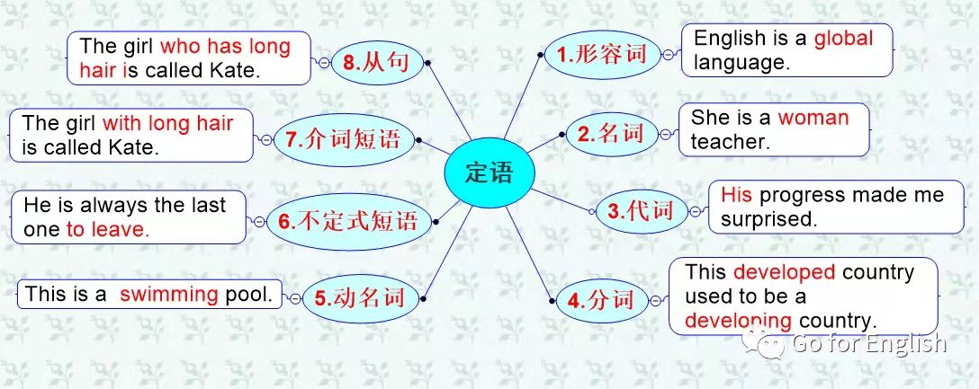

归纳1：

定语修饰名词或代词，说明其品质或特征

单个词位于被修饰词的前面，短语或从句位于被修饰词的后面

Map 2
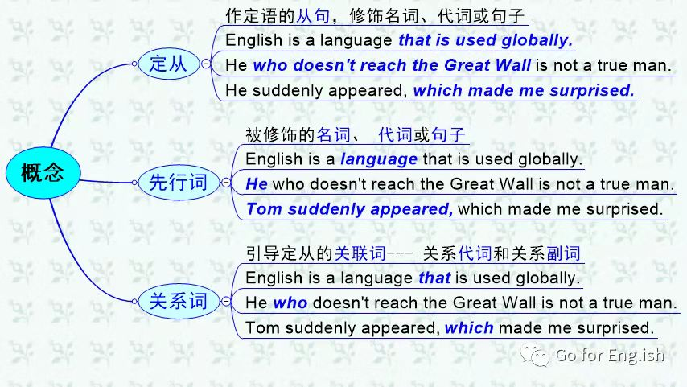

归纳2：

定语从句：修饰一个名词、代词或句子的从句称为定语从句

先行词：被修饰的名词、代词或句子称为先行词

关系词：引导定语从句的关联词称为关系词，包括关系代词和关系副词

Map 3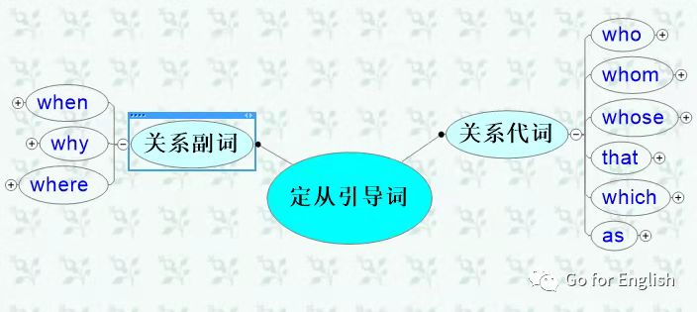
归纳3：

引导定从的关系代词有 who，whom，whose，that，which，as

引导定从的关系副词有 when，why，where

Map 4
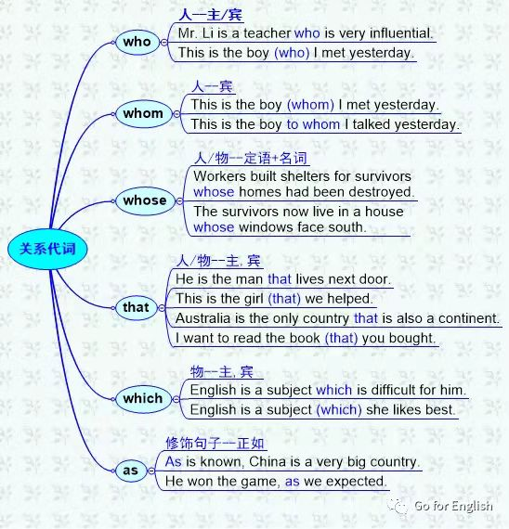
归纳4：

who修饰人，在定从中可作主语、宾语，作宾语时可省略

whom 修饰人，在定从中作宾语，可省略，但前面有介词时不能省

whose 修饰人或物，在定从中作定语，后跟名词

that 修饰人或物，在定从中作主语或宾语，作宾语时可省略

which 修饰物，在定从中作主语或宾语，作宾语时可省略

as 修饰整个句子，意为“正如---”

Map 5
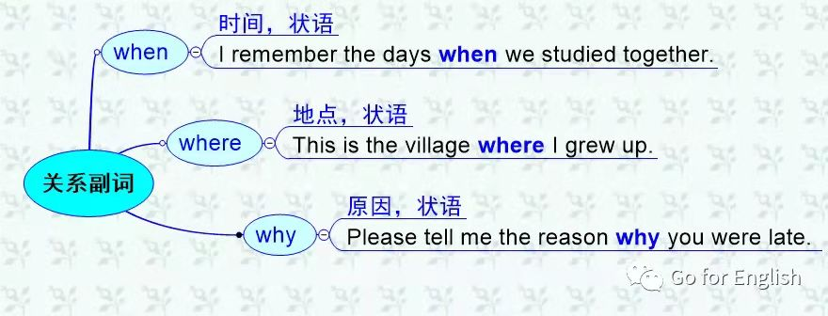
归纳5：

when 修饰表示时间的名词，在定从中作时间状语

where 修饰表示地点的名词，在定从中作地点状语

why 修饰表示原因的名词，在定从中作原因状语

*Look at the following summary and put it in mind.
记住以下小结
Map 6
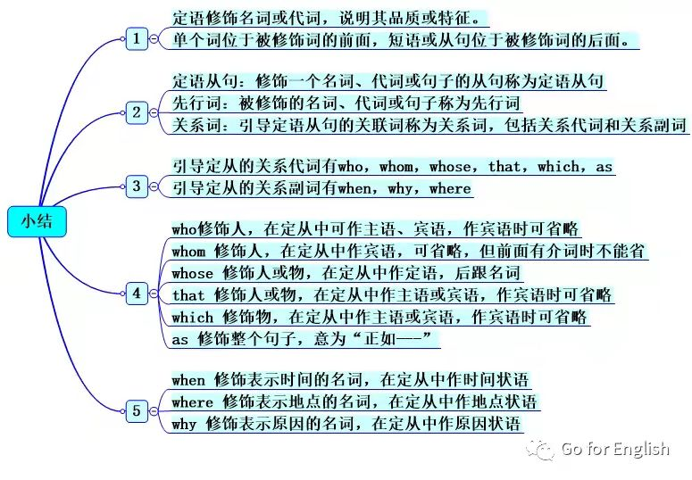
Try the following exercises
巩固练习
1.The place_______interested me most was the Children's Palace.
A. which B. where C. what D. in which
2.Do you know the man _______?
A. whom I spoke B. to who spoke C. I spoke to D. that I spoke
3.This is the hotel _______last month.
A. which they stayed B. at that they stayed
C. where they stayed at D. where they stayed
4.Do you know the year ______the Chinese Communist Party was founded?
A. which B. that C. when D. on which
5.That is the day______I'll never forget.
A. which B. on which C. in which D. when
6.The factory______we'll visit next week is not far from here.
A. where B. to which C. which D. in which
7.Great changes have taken place since then in the factory _______we are working.
A. where B. that C. which D. there
8.This is one of the best films _______.
A. that have been shown this year B. that have shown
C. that has been shown this year D. that you talked
9.Can you lend me the book ______the other day?
A. about which you talked B. which you talked
C. about that you talked D. that you talked
10.He is good at English, ______we all know.
A. that B. as C.whom D. what

练习答案
ACDCA CAAAB

