Unit 2 Office
Learning objectives
1.In warming-up: Students can organize their activities in one day and make a time schedule
2. In Reading A : grasp the main idea of the text and find out the duties and skills mentioned in the passage.; learn the useful words and phrases;
3. In Reading B: practical reading about industries newsletter.
4.
Warming-up
Task Read Mr. Thomson’s schedule for Tuesday. Write your schedule for today.
Tuesday
08:30 | Take the car for a service.
09:00 | Study the sales data of last month.
10:30 | Discuss sales with Mr. Black.
12:00 | Have working lunch with all managers.
13:30 | Ring the dentist.
14:00 | Make plans for next week’s sales conference.
17:00 | Collect the car from the garage.
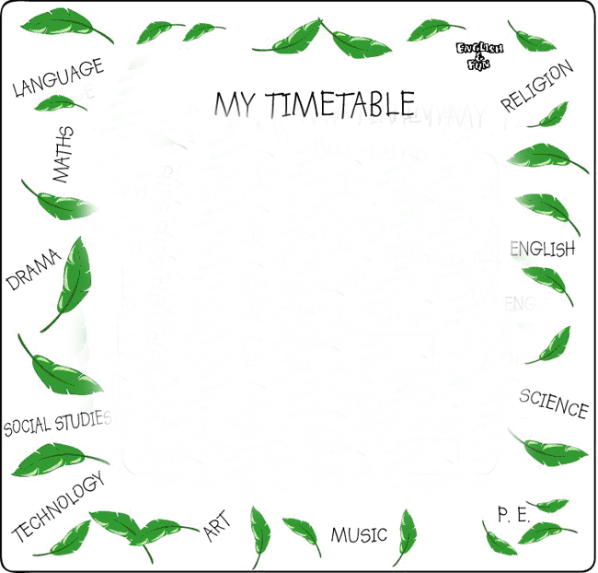
注意：活动日程表的目的是让有关人员清楚了解一项活动具体安排的时间、地点以及主管人员等。在日程表的开头要用醒目的字体写明是什么活动的安排计划；然后每项中先写明具体时间，再写活动内容、地点或负责人等。排列按时间顺序依次书写即可。书写时，一般用名词短语或分词替代完整的句子以求简练。
Reading A
Step 1 Words study
1. Lead the students to read the new words after the tape twice and
correct their pronunciations while reading.
2. Ask some students to read the new words to check whether they
have mastered the pronunciations of the words.
3. Explanation for some important and useful words
1) reflect verb
(1)show the image of somebody/something on the surface of something such as a mirror, water or glass 反映；映出（影像） VN usually passive ~ sb/sth (in sth)

(2) throw back light, heat, sound, etc. from a surface 反射（声、光、热等） VN

(3)表明，表达（事物的自然属性或人们的态度、情感等） VN

(4)think carefully and deeply about something 认真思考；沉思 ~ (on/upon sth)

reflect well, badly, etc. on somebody/something
to make somebody/something appear to be good, bad, etc. to other people 使给人以好的（坏的或其他）印象
2) appropriate adj.
(1)table, acceptable or correct for the particular circumstances 合适的；恰当的 ~ (for/to sth)

inappropriate Antonym appropriately adv.appropriateness n.
3)personnel noun
(1) people who work for an organization or one of the armed forces （组织或军队中的）全体人员，职员 plural

(2) department in a company that deals with employing and training people 人事部门 U + sing./pl. verb
See also: human resources
4) anticipate verb
(1)expect something 预料；预期

see what might happen in the future and take action to prepare for it 预见，预计（并做准备）
VN
(3)to think with pleasure and excitement about something that is going to happen 期盼；期望

5) confidential adjective
(1)meant to be kept secret and not told to or shared with other people 机密的；保密的；秘密的

(2) showing that what you are saying is private or secret 隐密的；秘密的

(3)trusted with private or secret information 受信任的；委以机密的 only before noun
Derivative: confidentially
6) prospect noun
(1)the possibility that something will happen 可能性；希望

(2)an idea of what might or will happen in the future 前景；展望；设想

(3)the chances of being successful 成功的机会；前景；前途 plural ~ (for/of sth)

(4)（竞赛中的）有望获胜者
(5)a wide view of an area of land, etc. 风景；景色
verb .to search an area for gold, minerals, oil, etc. 探矿；勘探 V ~ (for sth)
7) individual adjective
(1)considered separately rather than as part of a group 单独的；个别的

(2)connected with one person; designed for one person 一个人的；供一人用的

noun
(1)a person considered separately rather than as part of a group 个人

(2)a person who is original and very different from others 与众不同的人；有个性的人

verb
(1)to do something or try to achieve something over a period of time 追求；致力于；执行；贯彻
(2)to continue to discuss, find out about or be involved in something 继续探讨（或追究、从事） VN
(3)to follow or chase somebody/something, especially in order to catch them 追逐；跟踪；追赶
9) a variety of
e.g. The girls come from a variety of different backgrounds.
10) depend on
e.g. 1. The price depends on the quality.
11) keep track of
e.g. It’s difficult to keep track of all the new discoveries in medicine.
12) deal with
e.g. They should deal properly and fairly with any complaint
Step 2 Extensive Reading
Pre-reading
1.Ask the students to discuss in pairs something about duties for a typical secretary.
then read text A quickly and tick off duties and skills mentioned in the passage.

What are the duties for a typical secretary? | Which skills are required in a good secretary?
- handling correspondence  - managing a filing system  - keeping track of schedules  - operating and maintaining  office equipment  - dealing with phone calls  - handling orders, budgeting  or bookkeeping  - managing training or other  personnel work | - being skillful in managing time  - understanding staff needs and  solving their problems  - handling customers’  complaints effectively  - being good at interpersonal  relations  - being skillful in handling  paperwork  - being able to settle office  chaos  - knowing how to deal with  other companies

2. Lead the students to read the text together part by part and ask them to answer some simple questions to check whether they have understood the passage or not.
Para 1
秘书可能会有很多其他不同的头衔，例如行政助理、文员或私人助理。尽管所有这些头衔都以行政工作为主旨，但它们却反映了不同种类的秘书工作。秘书岗位十分古老，例如，古希腊和罗马的商人和政客们就曾雇用私人秘书和文员来管理他们的事务。
Para 2
1.Secretaries have a wide range of duties, depending on the offices that they work for.
现在分词作状语，表示补充说明。
2..秘书的工作就是使办公室顺利运转。秘书的职责范围很广，依据他们所在办公室的不同而各异。就最低要求来说，秘书要处理信函，跟踪日程安排，管理文件系统，操作电话、传真机、复印机等办公设备。许多秘书还要接听电话，并将其转给适当的人员。有些秘书还要负责办公室用品的采购，他们也可能会处理预算、簿记和人事文档。秘书应当具备使用电脑和其他电子设备的经验，因为他们将处理大量的电子资料，包括往来信函。
Para 3
They anticipate the needs of office staff, solve problems quickly, and work so efficiently that many people do not realize how valuable they are until they leave the job.
so... that...句型中的so是副词，常常用来修饰形容词或副词，意思是“如此……以致于……”，引导结果状语从句，常用句型为：主语+谓语+so+adj/adv+that从句。例如：
1). he is so young that she can't look after herself.
2). The boy ran so fast that I couldn't catch him.
3). He was so angry that he couldn't say a word.
until用于否定句中，表示句子的动作直到until短语所表示的时间才开始发生，即表示动作的起点。一般译为“直到……才”或“直到……之前(……还不)” 。
1) The secret was never told until after the old man's death. 这个秘密在老人去世后才说出来。
2) Don't open it until your birthday. 等到你过生日那天再打开。
3) She didn't sleep until eight. 她八点钟才睡觉。
Para 4
秘书行业的就业前景通常很好，对有经验者尤其如此。许多职业学校为有意当秘书的人们提供了培训课程。这些课程包括打字、文件管理、文件归档，以及一个好的秘书在工作中所必须具备的其他技能。虽然没有这些培训要获得秘书职位也是有可能的，但这在一个越来越专业化的社会里可能非常具有挑战性
Step 3. Exercise
Lead the students to discuss Task 2 and try to correct the statements without rereading the passage. Then check the answers together.
Step 4. Assignments
1.Task 3 of language lab
2.Exercises. on the workbook
Practical Writing (Agenda)
- Agendas议程
A. Definition and its layout
Agenda is a list of the subjects to be dealt with or talked about at a meeting. It always puts the title, date, time and venue (place) at the top. Late for meetings and committee meetings may also include the following:
- Apologizes for absence
- Matters arising from last meeting
- Correspondence
- Date of next meeting
Besides, for other relevant issues that were not included in the agenda, A.O.B., which means any other business, can be used at the bottom. A typical agenda is as shown below:

Title

Date;
Time:
Venue

body

- Minutes
A. Definition and its layout
Meetings are of different kinds. During a meeting an important company officer is assigned to take notes of the business discussed, decisions taken and so on. These notes are called minutes. It is a common practice that the minutes of the meeting are to be issued for all those who have attended the meeting to sign as a final acceptance of what has been reached during the meeting.
For most business meetings, action minutes are more useful than full minutes. The layout of the minutes is shown below

Grammar (Tenses)
英语时态与相关动词形式对应表
时 态 |  | 选用动词形式 |  | 助动词
一般 | 现 在 | 限定  动词 | 现在式（do） | 直接接主语
一般 | 过 去 | 限定  动词 | 过去式（v＋ed） | 直接接主语
一般 | 将 来 | 非  限  定  动  词  （不能直接接主语） | 动词原形  不定式［（to）do］ | will
一般 | 过去将来 | 非  限  定  动  词  （不能直接接主语） | 动词原形  不定式［（to）do］ | would
进 行 | 现 在 | 非  限  定  动  词  （不能直接接主语） | 现在分词  v+ing | am, is, are
进 行 | 过 去 | 非  限  定  动  词  （不能直接接主语） | 现在分词  v+ing | was, were
进 行 | 将 来 | 非  限  定  动  词  （不能直接接主语） | 现在分词  v+ing | will be
进 行 | 过去将来 | 非  限  定  动  词  （不能直接接主语） | 现在分词  v+ing | would be
完成 | 现 在 | 非  限  定  动  词  （不能直接接主语） | 过去分词  t-ed | have (has)
完成 | 过 去 | 非  限  定  动  词  （不能直接接主语） | 过去分词  t-ed | had
完成 | 将 来 | 非  限  定  动  词  （不能直接接主语） | 过去分词  t-ed | will have
完成 | 过去将来 | 非  限  定  动  词  （不能直接接主语） | 过去分词  t-ed | would have
完成进行 | 现 在 | 非  限  定  动  词  （不能直接接主语） | been+现在分词  (been v+ing) | 同完成时态
完成进行 | 过 去 | 非  限  定  动  词  （不能直接接主语） | been+现在分词  (been v+ing) | 同完成时态
完成进行 | 将 来 | 非  限  定  动  词  （不能直接接主语） | been+现在分词  (been v+ing) | 同完成时态
完成进行 | 过去将来 | 非  限  定  动  词  （不能直接接主语） | been+现在分词  (been v+ing) | 同完成时态
Listening & Speaking
Step 1. Introducing
1.Introduce to the students what they will hear and ask them to go
through the form quickly.
2.Lead the students to do the listening practice. The first listening is for the students to be familiar with the listening material and try to fill some blanks. The second listening is for the students to fill almost all the blanks. The third listening is for them to fill the
left blanks and check their own answers.
3.Ask several students to introduce themselves to the classmates one by one quickly.
Step 2. Getting to Know the topic
1.Introduce to the students that they will hear two dialogues about the topic.
2.Lead the students to learn the new words and expressions above each dialogue.
3.Lead the students to listen to each dialogue and try to fill all the blanks after listening to them for three times.
4.Invite a few groups to perform the dialogues and ask others to check their answers during their performance.
5.Ask one or two students to summarize each dialogue according to the questions listed after each dialogue.
Step 3. Listening Practice
1.Ask the students to listen to five very short dialogues and try to tick out what kinds of topic each dialogue talks about. Then check it together.
2. Listen to five short dialogues and try to tick out the correct answer to the question after each dialogue. Then check it.
3.Listen to five short dialogues and try to choose the appropriate answer to the question after each dialogue.
4.Give one minute to the students to go through the short passage. Then lead the students to listen to the passage twice and to fill the blanks. Then ask several students to read and give their answers and check it.
5.Listen to the passage again and answer some simple questions quickly. (The students had better retell the short passage.)

