Listen to the passage twice and fill in the information on the graph.
THE TOTAL VALUE OF EXPORT AND IMPORT COMMODITIES OF THE CAPITAL OF THE COUNTRY BETWEEN 2006 AND2010
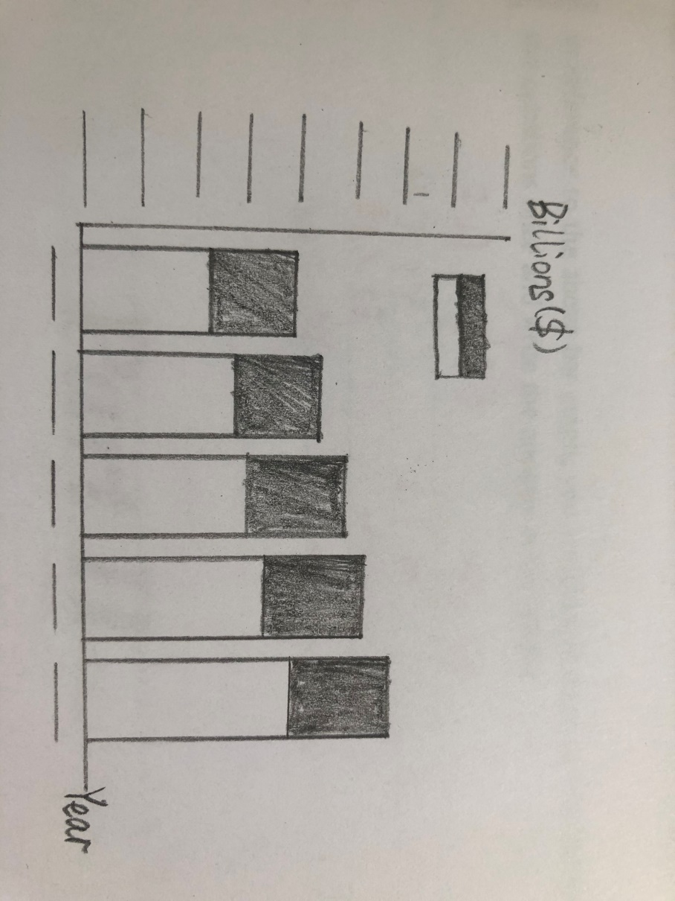
B
In reference to the above bar graph, you are going to listen to 4 questions. Listen to the questions once and write the answers in the blanks.
1
2
3
4
Conversations
A Listen to the following short conversations twice and fill in the blanks with the missing words.
1 Woman: Are you going to take that job the insurance company ?
Man: Oh, I’m not sure. There are to my present job, but the insurance company is offering me .
2 Woman: Robert worked as for three years. Then he became a . After that he started .
Man: I know. And he has been doing ever since.
3 Man: Well, I thought you were working for a large .
Woman: I did for a few months, but I decided that
wasn’t what I wanted to do.
4 Man: She wants to apply for the job, but she is
really , I’m afraid.
Woman: That’s a pity. She seems . Don’t you think we could train her?
5Woman:Will you need an experienced clerk for your hotel next summer?
Man: Do you have experience in work?
B
Listen to the following short conversations once and choose the
right answer to each question you hear.
- A. A temporary job.
B. A permanent job.
C. Some money for the vacation.
D. Some money for the university fees.
- A. He found his new job disappointing.
B. He’s discouraged because he didn’t get the job.
C. He wanted to hire someone else for the job.
D. He hasn’t made an appointment for the job interview.
3 A. Help the woman.
B. Type some letters.
C. Go home at five o’clock.
D. Work together with Mr. Smith.
4 A. Try harder to locate work.
B. Give up looking for a job.
C. Ask his stepfather for a job.
D. Travel instead of working this summer.
- A. He’s indifferent toward it.
B. He hates it.
C. He enjoys it.
D. He minds all the overtime.

