English for Careers 1

Unit 8 Career
Teaching objective
After studying this unit, the students are able to master the key words and structures, and more importantly, to communicate for the following purposes:
- understanding hot career fields in the next decade
- understanding a job ad
- going for an interview
- understanding and writing a résumé
- performing a job interview
- mastering nonfinite verbs

The method of approach
- Discussing, listening, reading, presenting, and role-playing by the students;
- Explanation and demonstration by the teacher;
- After-class research and practice by the students.
Unit content
Reading A: Career Trends
Reading B: McDonald’s Corporate Careers
Listening & Speaking: Job Hunting
Writing: Résumé
Mini-project: Job Interview
Grammar: Nonfinite Verbs
Time requirement: 8-9 periods

Unit Focus

decade relate to ensure guarantee
attributable to in demand expand conscious
in the face of open out identification primarily
assessment positive

Teaching procedures

This unit is arranged for a time span of 8 hours, during which a time limit is suggested for each step. Though it’s always important to keep a time limit in mind for each activity, a teacher should never stick to a rigid time plan in teaching, but rather follow a more flexible time table when dealing with unexpected in-class occurrences and make necessary adjustments accordingly. Note that not every step suggested here is a must in teaching. A teacher can make whatever changes he thinks necessary.
Hour 1:

Course introduction 45 minutes
Warming-up

Task 1 10 minutes

Objective: Ss learn the basic parts of a job advertisement.
Steps:
• Ss read Warming-up Task 1.
• Go through the job offer with Ss and ask them to match descriptions A-E with their corresponding parts 1-5 in the ad.
• Give the key.

Key: 1–D 2–E 3–B 4–A 5–C

Task 2 10 minutes

Objective: Ss can identify their preferences for future careers..
Steps:
• Ss read Warming-up Task 2.
• Get Ss to work in pairs and discuss the question.
• Ask some pairs to present their work.
• Comment briefly on their work.

New words in Reading A 15 minutes
Objective: Ss can get familiar with the new words and expressions, etc..
Steps:
• Ss listen to the new words and expressions, etc.
• Ss read the new words and expressions, etc.

Notes: For a class with higher English proficiency, the teacher may follow the following steps:
• Ss preview the new words and expressions.
• Ss read the new words and expressions.
• Ss dictate several important new words and expressions.

Discussions before Reading A 10 minutes
Objective: Ss can get familiar with the new words and expressions, etc..
Steps:
• Ss know something about Reading A.
• Ss discuss the following two questions:
- What are going to be the three hot career fields in the next decade?
- What must your choice of career depend primarily on?
• Comment briefly on their work.

Hours 2-3:

Reading A 45 minutes
Language points 35 minutes

Paragraph 1
decade: n. a period of ten years
e.g. That was the first meeting between the two companies in more than a decade.

Paragraph 2
relate to: to be connected with
e.g. This relates to something I mentioned earlier.
ensure: v. to make it certain that something will happen
e.g. All the necessary steps have been taken to ensure the safety of the children.
His wife ensured that he took his pills every day.

Paragraph 3
guarantee: v. to promise that something will certainly happen or be done
e.g. Take this opportunity, and I guarantee you won’t regret it.
attributable to: likely to have been caused by something
e.g. His death was attributable to gunshot wounds.
in demand: greatly desired
e.g. Skilled workers are in great demand in this city.
Paragraph 4
expand: v. to become larger in size, number or amount, or to make something become larger
e.g. The population of the town expanded rapidly in the 1990s.
conscious: a. noticing or realizing something; aware
e.g. I was very conscious of the fact that I had to make a good impression.
Are you conscious how people will regard such behavior?
in the face of: before; in the presence of
e.g. What could he do in the face of all these difficulties?
open out: to become wider; to develop
e.g. The path opens out into a courtyard behind the houses.
Business has been opening out recently.

Paragraph 5
identification: n. the act or process of recognizing something
e.g. Correct identification of consumers’ needs is important to the success of business.
primarily: ad. mainly
e.g. This research is concerned primarily with prevention of the disease.
assessment: n. a process of making a judgment about a person or situation
e.g. What’s the CEO’s assessment of the situation?
The investigation was reopened after careful assessment of the new evidence.
positive: a. believing that good things will happen or that a situation will get better; good, useful
e.g. You’ve got to be more positive about your work.
At least something positive has come out of the situation.
… all the education and training in the world will not get you very far.
… all the education and training in the world will not help you much.
e.g. With housing prices at this high level, $50,000 won’t get you very far.

Task 1 5 minutes
Objective: Ss can find some specific information in the passage.
Steps:
• Ss do Task 1.
• Ask Ss to work individually.
• Check the answers.
Suggested Answers:
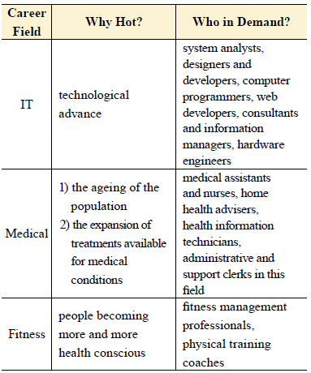

Task 2 5 minutes
Objective: Ss can find some specific information in the passage.
Steps:
•Ss do Task 2.
• Ask Ss to work individually.
• Check the answers.

Suggested Answers:
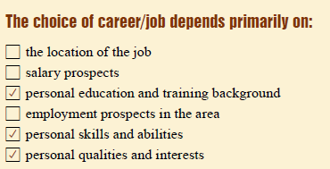
Task 3
Objective: Ss can speak well based on the topic of Reading A.
Steps:
•Ss do Task 3.
• Ask Ss to work in pairs.
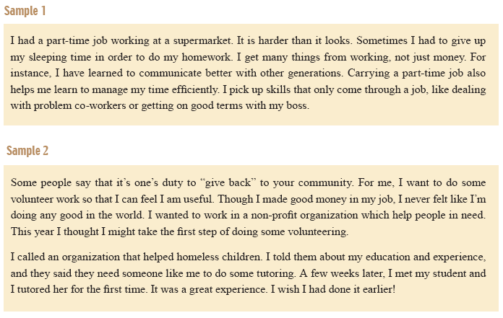

Language lab 45 minutes
Task 1 5 minutes
Objective: Ss know the spelling and meaning of the words and expressions from Reading A.
Steps:
• Ss read Task 1.
• Allow Ss 5 minutes to do the task.
• Check the answers.
Key
Key: 1. G 2. I 3. E 4. A 5. H 6. B 7. J 8. D 9. C 10. F

Task 2 10 minutes
Objective: Ss can use the words and expressions from Reading A.
Steps:
• Ss do Task 2.
• Ask Ss to work individually.
• Check the answers.

Answers
1. career 2. expanded 3. relates to 4. positive
5. decade 6. identification 7. assessment 8. guarantee
9. trend 10. Statistics

Task 3 10 minutes
Objective: Ss can use the given words and expressions.
Steps:
• Ss do Task 3.
• Ask Ss to work individually.
• Check the answers.

Key:
1. available
2. ensure
3. attributable
4. As a result
5. No matter how

Task 4 10 minutes
Objective: Ss can express ideas in writing using the two models outlined for Task 4.
Steps:
• Read the models to Ss with an explanation if needed.
• Ss work in pairs.
• Check the answers.

Key:
Model 1
1. It is necessary that all the risks should be calculated in advance.
2. It is a great pleasure that I share my favorite books with friends.
3. It is a pity that I haven’t been to the Great Wall.
Model 2
1. No matter how cold it is, she always goes swimming.
2. No matter who commits the crime, the judge shall sentence him to ten years in prison.
3. No matter what I suggest, he always disagrees.

Task 5 10 minutes
Objective: Ss can use the vocabulary in Reading A for translation.
Steps:
• Ss work individually or in pairs and translate the sentences.
• Ask two Ss to write their translations on the board.
• Comment briefly on their work with emphasis on the structures of their sentences.

Key:
1. I can’t ensure that you get a satisfactory result.
2. Oil is in great demand these days.
3. She behaved bravely in the face of danger.
4. The scope of the company’s business is rapidly expanding.
5. I was not conscious of having made a mistake.
6. They want to spend a minimum of both time and money to get the best result.
7. I did it on my own responsibility, without being told.
8. In marketing teamwork is more important than individual effort.

Hours 4-5:

Listening 45 minutes
Task 1 5 minutes
Objective: Ss can accurately write down the missing information.
Script:
M: Thank you for giving me this opportunity, Ms. Chen.
W: You are welcome, Mr. Li. Please sit down. Well, first I’d like to know something about your present job and what you’ve done up to now.
M: Sure. I am a graduate of Tsinghua University and have been working as a mechanical engineer with TMC Technologies for about five years.
W: That’s very impressive. Then do you have any particular reason for changing the job?
M: Well, right now I am looking for a growth opportunity, which I feel is not available at my current employer.
W: I see. What are some of your responsibilities…?
(FADE OUT)
Q1: Where did the man graduate?
Q2: What is the man’s present job?
Q3: Why does the man want to change his job?
Key
Key: 1. B 2. C 3. D

Task 2 10 minutes
Objective: Ss can accurately the people with their job titles.
Script:
M: Ms. Wright, as you know I’ve been thinking about moving my career in a new direction. I hope that you can provide me with a reference for my job hunting.
W: Sure. I am glad to.
M: Thanks. You know, I’ve really enjoyed working here and I’ve grown both personally and professionally with your help.
W: It’s a pleasure to work with you too. I won’t forget what you have done for our department.
M: It’s really hard to say goodbye. The company is like a family to me.
W: My feelings are mixed too. By helping you I’m losing a valuable employee. However I think you deserve a better prospect.

Key:
1. F moving his career in another direction
2. F She’s glad to do so.
3. T 4. T

Task 3 10 minutes
Objective: Ss can decide whether the statements are true or false.
Script:
M: Any interesting jobs in today’s newspaper?
W: Well, there are a lot of sales positions: selling books and stuff. But you have to work in the evening and on weekends.
M: Hmm. I hate working on weekends.
W: Oh, look here, it is a job of selling furniture.
M: Selling furniture? That sounds interesting.
W: Yeah. Let me see. You only have to work from 9 a.m. to 6 p.m. on weekdays. But you need to have a driver’s license and sometimes you may have to carry heavy pieces of furniture.
M: I enjoy driving and I am strong. The job sounds perfect for me. How can I contact them?
W: You may call this number.
Key
Key:
selling furniture
have to be physically strong
working on weekdays
need to have a driver’s license

Task 4 10 minutes
Objective: Ss can understand the conversation and choose the best answer.
Script:
M: Please sit down. You are Sally Huang, right?
W: Yes. It’s a pleasure to meet you.
M: Nice to meet you, too. Well, can you tell me about your education first?
W: Sure. I got my B.A. from Beijing Foreign Studies University and then I pursued my further study for M.A. in UBC in Canada.
M: What did you study for both of your degrees?
W: Well, I studied English for my first degree and Education Management for my graduate degree.
M: That’s quite impressive. And what kind of jobs have you had?
W: I worked at New Star Education for three years, and then I began to work for Express English. I’ve been working there for about two years.
M: What do you do there?
W: I’m a secretary, organizing classes and handling complaints from students.
M: I see. Why do you choose to leave your current you choose to leave your current position then?
W: Well, I’ve always wanted to be a teacher ever since I was a child. Moreover, I enjoy being with children.
M: OK. That’s all for my questions. Thank you for coming. You’ll be hearing from us within ten days.

Key:
Ke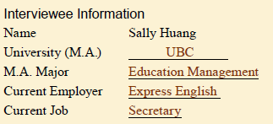y

Task 5 10 minutes
Objective: Ss can find specific information from listening to a passage related to the theme.
Script & Key:
An interview gives you the opportunity to show your qualifications to a prospective employer, so it pays to be well prepared. The following provides some helpful ideas.
Make sure your interview clothes are neat, tidy and suitable for the type of firm you are interviewing with. Bring several copies of your résumé. Know the exact place and time of the interview and arrive five to ten minutes earlier.
During the job interview try to relax and stay as calm as possible. Keep eye contact with the interviewers. Listen very carefully to each question you are asked and give thoughtful, to-the-point and honest answers. Make sure you understand the employer’s next step in the hiring process; know when and from whom you should expect to hear next. When the interviewer concludes the interview, thank him or her for the time and confirm how you are to follow-up.
Always send a thank-you letter to the interviewer immediately. It is good to keep the letter short but to also restate your interest in the position and your confidence in your qualifications.

Speaking 45 minutes
Task 6 45 minutes
Objective: Ss are able to role play a job interview with the useful expressions.
Steps:
• Ss read Task 6.
• Ss work in pairs to role play a job interview.
• Ss complete the chart.

Tips:
Self-expression during an interview
It’s always best to appear clean, neat and professional. What this means is as follows:
• Remove all facial piercings (women can leave earrings in, but smaller is better).
• Men can have facial hair; just make sure it’s neatly trimmed.
• If possible, make sure your hair coloring is somewhat normal. Avoid blue, green, purple, etc.
• Dress appropriately for the position. You should always be dressed more formally than those interviewing you (unless the person who set up the interview tells you otherwise).
• Shower before the interview and avoid perfumes or colognes with strong scents. Also, don’t smoke right before an interview. Some people are allergic to certain scents.
• Speak clearly and professional. Avoid slang and similar language that’s not appropriate for a work or business setting.
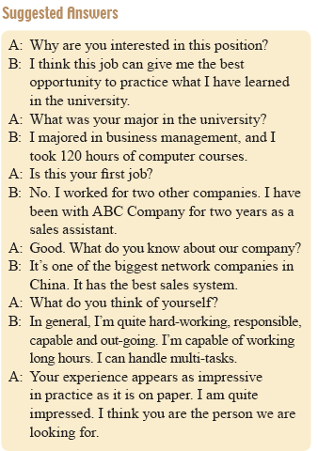
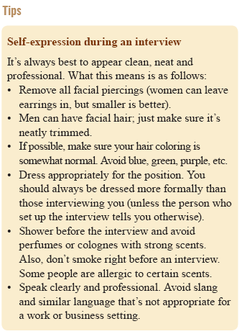

Hours 6-7:

Reading B 45 minutes
New words 5 minutes
Objective: Ss can get familiar with the new words and expressions, etc.
Steps:
• Ss listen to the new words and expressions, etc.
• Ss read the new words and expressions, etc.

Fast reading 20 minutes
Objective: Ss can comprehend Reading B.
Steps:
• Ss read the passage.
• Provide help if needed.

Task 1 10 minutes
Objective: Ss can decide whether the following statements are true or false according to the passage.
Steps:
• Ss read the passage.
• Ss complete the task.
• Ss compare their work with others.
• Select Ss to present their work.
Key
Key: 1. F 2. T 3. F 4. F 5. F

Task 2 10 minutes
Objective: Ss can comprehend the specific information taken from the given text.
Steps:
• Ss read the passage.
• Ss complete the task.
• Ss compare their work with others.
• Select Ss to present their work.

Sample:
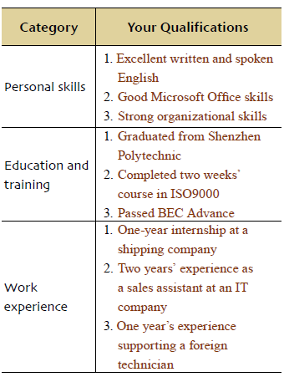

Writing 45 minutes
Task 1 15 minutes
Objective: Ss can get familiar with the style of résumé.
Steps:
• Ss do the task individually.
• Ss compare with each other’s answers.
• Provide help if needed.
• Present the answers.

Suggested Answers:
1. A résumé is a summary of one’s qualifications, which describes him/her and shows what he/she can do. It should make a good first impression to a potential employer. The employer will decide whether he/she is qualified or not for their position according to the résumé. Also, the employer will use the résumé to determine whether to bring him/her into the office for an interview. Therefore, a good résumé is important in job-seeking.
2. Appearance is important, but content is even more crucial. The information in one’s résumé needs to be well organized, easy to read and results-oriented. It should address the employer’s needs and show the employer how he/she will benefit. It should focus on his/her achievements and career goals…
3. A résumé usually includes one’s personal information, objective, education details, work experience, skills, interest, personality, and so on.

Task 2 15 minutes
Objective: Ss can get familiar with the style of résumé.
Steps:
• Ss do the task individually.
• Ss compare with each other’s answers.
• Provide help if needed.
• Present the answers.

Sample:
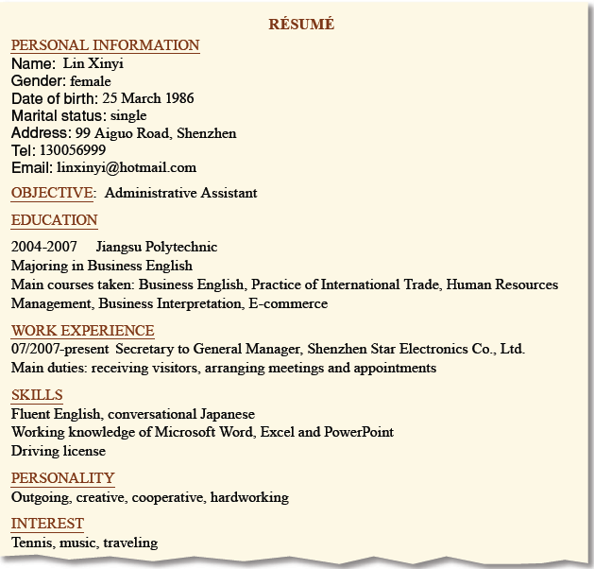

Task 3 15 minutes
Objective: Ss can get familiar with the style of résumé.
Steps:
• Ss do the task individually.
• Ss compare with each other’s answers.
• Provide help if needed.
• Present the answers.

Key: (open)

Hour 8:

Mini-Project 40 minutes
Objective: Ss can know how to perform a job interview.
Steps:
• Grouping. Divide the class into groups.
• Defining the project. Go through the project with the class and clarify requirements. You are advised to do it after Ss study Listening & Speaking.
• Timing & cooperation. Give Ss the deadline for completion and guidelines on working together. Ss who take the role of interviewers need to prepare questions beforehand, while those who are interviewees should prepare résumés.
• Co-working
1) Ss decide positions for each interviewee.
2) Ss acting as interviewees prepare résumés and present them to interviewers 1 day before the interview.
3) Ss acting as interviewees anticipate interview questions and practice answers before the interview.
4) Ss acting as interviewees answer questions during the interview.
5) Ss acting as interviewers read the résumés and preparing questions before the interview.
6) Ss acting as interviewers ask questions and fill in the observation sheets during the interview.
7) Both interviewees and interviewers pay attention to the interview etiquettes.
8) Ask 2 or 3 groups to present their interviews to the class.
9) Invite other groups to give comments.

Quiz 5 minutes

