English for Careers 1

Unit 4 Product
Teaching objective
After studying this unit, the students are able to master the key words and structures, and more importantly, to communicate for the following purposes:
- understanding industrial designers’ job
- understanding a new product’s manual
- talking about products
- understanding and writing a producing a catalog
- demonstrating the function of a product
- mastering subject-verb agreement

The method of approach
- Discussing, listening, reading, presenting, and role-playing by the students;
- Explanation and demonstration by the teacher;
- After-class research and practice by the students.
Unit content
Reading A: Our Heritage
Reading B: ipod Safety Manual
Listening & Speaking: Talking About Products
Writing: Catalog
Mini-project: Describing a Process
Grammar: Subject-Verb Agreement
Time requirement: 7-8 periods

Unit Focus

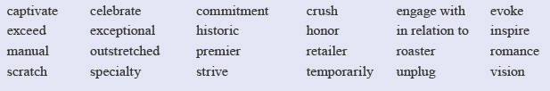

Teaching procedures

This unit is arranged for a time span of 8 hours, during which a time limit is suggested for each step. Though it’s always important to keep a time limit in mind for each activity, a teacher should never stick to a rigid time plan in teaching, but rather follow a more flexible time table when dealing with unexpected in-class occurrences and make necessary adjustments accordingly. Note that not every step suggested here is a must in teaching. A teacher can make whatever changes he thinks necessary.
Hour 1:

Course introduction 45 minutes
Warming-up

Task 1 10 minutes

Objective: Ss can identify the differences between two products and explain their preferences.
Steps:
• Ss read Warming-up Task 1.
• Go through the sample with Ss.
• Get Ss to do the task in pairs, e.g. one student asks questions and the other answers.
• Ask some pairs to role-play their dialogs in front of the class, giving comments when necessary.

Task 2 10 minutes

Objective: Ss know what factors to consider before they buy a product.
Steps:
• Ss read Warming-up Task 2.
• Ask Ss to work in pairs to work out the answers to the questions.
• Get some Ss to give their answers.
• Ask the class for different ideas.
• Comment briefly.

Suggested answers:
Before you make purchase of any product, there are some factors you should consider.
• Necessity: Do I really need this?
• Property: Do I really like this? Am I really satisfied with the quality, color, shape, packaging, etc?
• Price: Do I have any spare money right now? Is it a bargain or is it too much money?
• Brand: What brand is the best choice for
my purchase?
• After-sales service: Does it come with a warranty?
• Shipment: How can it be sent to my house?

New words in Reading A 15 minutes
Objective: Ss can get familiar with the new words and expressions, etc.
Steps:
• Ss listen to the new words and expressions, etc.
• Ss read the new words and expressions, etc.

Notes: For a class with higher English proficiency, the teacher may follow the following steps:
• Ss preview the new words and expressions.
• Ss read the new words and expressions.
• Ss dictate several important new words and expressions.

Discussions before Reading A 10 minutes
Objective: Ss can get familiar with the new words and expressions, etc.
Steps:
• Ss know something about Reading A.
• Ss discuss the following two questions:
- Have you ever heard of Starbucks?
- Have you heard of Moby-Dick?
• Comment briefly on their work.

Hours 2-3:

Reading A 45 minutes
Language points 35 minutes
Paragraph 1
It was true when the first Starbucks opened in 1971, and it’s just as true today: Today, it is just as true as it was in 1971 when the first Starbucks opened.
Paragraph 2
inspire: v. to give (someone) an idea about what to do or create
e.g. His sad childhood inspired him to write a novel.
evoke: v. to cause (a particular reaction or response) to happen
e.g. These pictures evoked his memories of those old movies.
Paragraph 3
From drinking his first cup of Sumatra coffee, Howard became drawn to Starbucks and he joined them a year later: From drinking his first cup of Sumatra coffee, Howard was attracted by Starbucks and he joined them a year later.
Paragraph 4
captivate: v. to attract and hold the attention of (someone) by being interesting, pretty, etc.
e.g. Her stories captivated the imagination of millions of children.
be captivated with/by
e.g. He became captivated with the idea of creating a piece of music that might be interesting to all.
We were immediately captivated by the beauty of this valley.
vision: n. someone’s idea or hope of how something should be done, or how it will be in the future
e.g. When he was still at college, he had a vision of building the highest tower in the world.
Paragraph 5
celebrate: v. to do something enjoyable because of a special occasion or to mark someone’s success
e.g. The event was celebrated by poets and historians.
... a feeling of connection: a feeling of being connected with each other, or a sense of being close to each other
Paragraph 6
honor: v. to do what you said you would do
e.g. He informed us that he was unable to honor his contract with the company.
… our commitment to: Here “to” is a preposition followed by a noun.
e.g. You should never forget your commitment to your people.
engage with…: to make an effort to understand and deal with someone or something
e.g. This famous actor knows how to engage with his audience.

Task 1, 2, 3 15 minutes
Task 1
Objective: Ss can find some specific information in the passage.
Steps:
• Ss read the passage.
• Ss complete the task.
• Ss compare their work with others.
• Select Ss to present their work.
Key
Key:

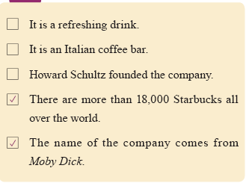
Task 2
Objective: Ss can decide whether the following statements are true or false according to the passage.
Steps:
• Ss read the passage.
• Ss complete the task.
• Ss compare their work with others.
• Select Ss to present their work.

Key: 1. F 2. T 3. T 4. T 5. T

Task 3
Objective: Ss can speak well based on the topic of Reading A.
Steps:
•Ss do Task 3.
• Ask Ss to work in pairs.

Sample
I like tea better. Both my parents like to drink tea every day. So it is natural for me to like it, too. For me, tea is not just some drink that keeps me awake when I am busy doing my work, it is also something that reminds me of my family.

Language lab 45 minutes
Task 1 5 minutes
Objective: Ss know the spelling and meaning of the words and expressions from Reading A.
Steps:
• Ss read Task 1.
• Allow Ss 5 minutes to do the task.
• Check the answers.
Key
Key: 1. F 2. G 3. H 4. I 5.J 6. B 7. E 8. C 9. A 10. D

Task 2 10 minutes
Objective: Ss can use the words and expressions from Reading A.
Steps:
• Ss do Task 2.
• Ask Ss to work individually.
• Check the answers.

Answers
1. heritage 2. specialty 3. evoked 4. captivated
5. inspired 6. honor 7. retailer 8. vision
9. strive 10. commitment

Task 3 10 minutes
Objective: Ss can express ideas in writing using the two models outlined for Task 3.
Steps:
• Read the models to Ss with an explanation if needed.
• Ss work in pairs.
• Check the answers.

Key:
Model 1
1. They not only understood the word, but also used it in a new sentence.
2. She not only finished the writing homework, but also practiced speaking with her roommate.
3. Tom is not only strong in swimming, but also good at basketball.
Model 2
1. She tried hard to be both a good mom and a successful teacher.
2. He liked both the computer games that he borrowed from his friends and the story books I bought for him.
3. Both Class 1 and Class 2 went to the West Park for a picnic yesterday.

Task 4 10 minutes
Objective: Ss can use the words and expressions from Reading A.
Steps:
• Ss do Task 4.
• Ask Ss to work individually.
• Check the answers.

Key: 1. C 2. A 3. D 4. C 5. B 6. B 7. A 8. A 9. B 10. C

Task 5 10 minutes
Objective: Ss can use the vocabulary in Reading A for translation.
Steps:
• Ss work individually or in pairs and translate the sentences.
• Ask two Ss to write their translations on the board.
• Comment briefly on their work with emphasis on the structures of their sentences.

Key:
1. He had a vision of making this small town a modern city.
2. This festival has become part of our cultural heritage.
3. We will strive to achieve our goal no matter how many difficulties there are in the future.
4. The Dragon Boat Festival is said to honor a great poet in history.
5. The tree by the house evoked a feeling of loneliness.
6. He seemed to have forgotten his commitment to the public.
7. The new movie was inspired by the true story of a blind girl.

8. The company has achieved a premier position in the electronics field.

Hours 4-5:

Listening 45 minutes
Task 1 5 minutes
Objective: Ss can accurately write down the missing information.
Script & Key:
M: Could you give me the size of the printer?
W: Yes. It’s 15 centimeters high.
M: How about its width?
W: It’s 30 centimeters wide.
M: How long is it?
W: The length is 65 centimeters.
M: By the way, how much does it weigh?
W: Its weight is 5 kilograms.

Task 2 10 minutes
Objective: Ss can accurately write down the missing information.
Script:
W: Could you tell me something about your beds, please?
M: Of course. What type of bed? We have three models.
W: What does Model 3 look like?
M: Well, it’s a double bed. Very popular in fact.
W: What’s it made of?
M: Wood, and it’s very comfortable.
W: What color does it come in?
M: It comes in brown, white or black.
W: How much does it weigh?
M: It’s heavy because of the wood. It weighs about 135 kilograms.
W: What is the price?
M: $515.

Key: Wood; Brown/White/Black; 135kg; $515

Task 3 10 minutes
Objective: Ss can accurately write down the missing information.
Script:
M: Anne, what do you think?
W: A pen is always a good idea—I mean, it’s really practical.
M: Yeah… but not very original. You know, I quite like the mouse pads—they’re a good price. The pictures are attractive.
W: Yes. We can have our logo on it!
M: Exactly. And I was also thinking of the business card case.
W: It’s a nice little item, uh-huh, but the price, you know we’d need hundreds of them. That’s far too expensive.
M: Point taken. So, what about a conference bag?
W: A conference bag? It’s not original, either.
M: But just think, we can have our logo and our contact details on it, and it’s a free ad. Moreover, it’s quite practical because people can put all their gifts in it!
W: That’s brilliant!

Key:
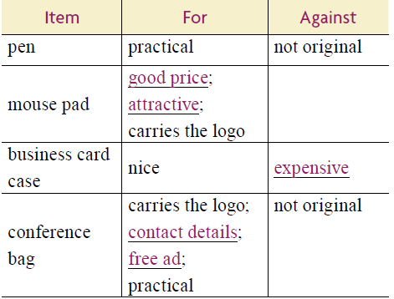

Task 4 10 minutes
Objective: Ss can understand the conversation and choose the points the woman mentions in her description.
Script:
W: Good morning, sir. Is there anything I can do for you?
M: Good morning. I’d like to buy a language translator.
W: Would you like to have a look at our language translators here?
M: Yes, thank you. Well, this one looks very nice. Can you tell me about this model?
W: Yes, of course. This model is our latest product. It was launched this winter. As you can see, it has an attractive shape. Compared with our other products, it is smaller in size and lighter in weight. It only weighs 80 grams. Its length, width and height are 12cm, 6cm and 3cm respectively. Small enough to put in your pocket, and so light it can travel with you wherever you go. This model has two colors available: white and grey.
M: How many words does it contain?
W: It contains over 10,000 words in 5 different languages. And you will also find it easy to use.
M: Would you please show me how to use it?
W: Sure. First select the source language, then type in a word, select the target language, press the button and it gives you an instant translation.
M: Oh, it’s very simple to use. Well, what is worrying me is its after-sales service.
W: I can assure you of its quality. We also offer you a two-year warranty.
M: How much is it?
W: It’s $90. I think this price is quite reasonable, compared with other products in terms of function and quality.
M: OK. I’ll take this model, in white, please.

Key:
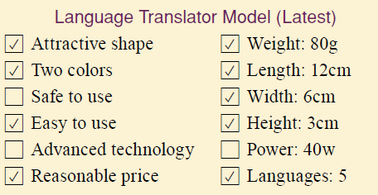

Task 5 10 minutes
Objective: Ss can find specific information from listening to a passage related to the theme.
Script & Key:
When describing your product for a business plan, you should start by asking yourself, “What product am I selling?” In answering the question, you can explain what the product is and what the product is used for. Then you can list the special points that make your product different from others. More importantly, you should state how your product will benefit customers.
The description of your product should clearly state goals and objectives. Describe the special points of your product and how or why it will attract customers. Emphasize any special points that you feel will attract customers and explain how and why these points are attractive. Try to describe the benefits of your product from your customers’ point of view. Successful business owners know or at least have an idea of what their customers want or expect from their product. This type of knowledge can be helpful in building customer satisfaction and loyalty.

Speaking 45 minutes
Task 6 45 minutes
Objective: Ss are able to describe any products (at hand) with the useful expressions.
Steps:
• Ss read Task 6.
• Ss work in pairs to describe any products at hand to their partners.
Suggested Answers
Color
A: What color is your mobile phone?
B: It’s black. It is my favorite color.
Shape
A: What shape is your mobile phone?
B: It’s square/rectangular.
Material
A: What are the garments made of?
B: Our silk garments are made of super pure silk material by traditional skills.
Function
A: What is the machine used for?
B: It is used for drilling.
Dialog A
A: Good morning. What can I do for you?
B: Yes, I’d like a hat.
A: What color do you like?
B: I like blue.
A: OK, here it is.
B: Is it made of cotton?
A: No, it isn’t.
B: Oh. What is it made of?
A: It’s made of wool.
B: I see. Thank you.
Dialog B
A: What’s in your bag?
B: A bottle and a cup.
A: What’s the bottle made of?
B: It’s made of glass.
A: What’s this bottle for?
B: It’s for milk.
A: What’s that cup for?
B: It’s for coffee.
A: Do you want a cup of tea?
B: No. Thanks.

Hours 6-7:

Reading B 45 minutes
New words 5 minutes
Objective: Ss can get familiar with the new words and expressions, etc.
Steps:
• Ss listen to the new words and expressions, etc.
• Ss read the new words and expressions, etc.

Fast reading 20 minutes
Objective: Ss can comprehend Reading B.
Steps:
• Ss read the passage.
• Provide help if needed.
• Select Ss to present their work.

Task 1 10 minutes
Objective: Ss can decide whether the following statements are true or false according to the passage.
Steps:
• Ss read the passage.
• Ss complete the task.
• Ss compare their work with others.
• Select Ss to present their work.
Key
Key: 1. F 2. T 3. F 4. F 5. F

Task 2 10 minutes
Objective: Ss can choose the right things to do in the following situations.
Steps:
• Ss read the task.
• Ss complete the task.
• Ss compare their work with others.
• Select Ss to present their work.

Key:
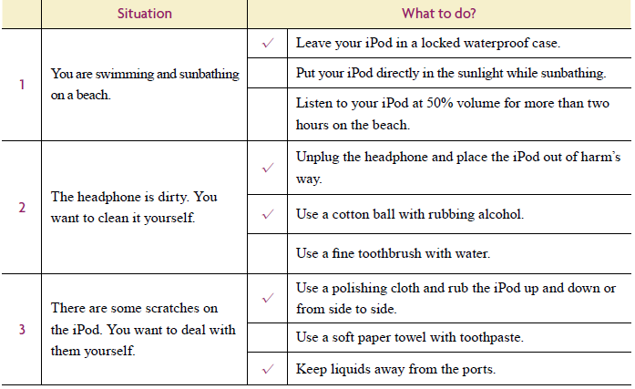

Writing 45 minutes
Task 1 20 minutes
Objective: Ss can get familiar with the style of catalog.
Steps:
• Ss do the task individually.
• Ss compare with each other’s answers.
• Provide help if needed.
• Present the answers.

Key:
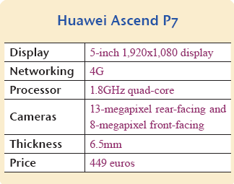

Task 2 25 minutes
Objective: Ss know how to write a catalog.
Steps:
• Ss do the task individually.
• Ss compare with each other’s answers.
• Provide help if needed.
• Present the answers.

Sample

A Clock Description

A poetic representation of time and those important moments of life that fly away, this unique butterfly clock in black comes in 3 separate pieces so that you can arrange the butterflies as you like. Perhaps there’s ametaphor to be found between the butterflies and time flying away. This creative timepiece can make a beautiful addition to any household. The 3 butterflies can be stuck on anywhere on the wall around the clock to make every clock special and unique. It allows you to create the DIY clock you like by switching the positions of the butterflies. It is powered by batteries, no cables or wiring is needed, and the special texture makes it easy to be cleaned. The perfect decorative clock for any living room, bedroom, studio or café makes any room stylish, unique and modern. Your choice of the clock shows your perfect sense of taste and lifestyle.

Product Specifications:
Material: plastic
Color: red
Powered By: 1 x AA battery (not included)
Size: 300mm (Diameter) x 50mm (thickness)
Weight: 0.28 kg

Hour 8:

Mini-Project 40 minutes
Objective: Ss can know how to demonstrate how to use a product.
Steps:
• Grouping. Divide the class into groups.
• Defining the project. Go through the project with the class and clarify requirements. You are advised to do it after Ss study Reading B.
• Timing & cooperation. Give Ss the deadline for completion and guidelines on working together. Remind them that different Ss have different work but everybody contributes to the project. Selecting an appropriate product is very important in this project. All group members should have their views out.
• Co-working
1) Ss choose one product.
2) Ss search information about the product and specify how to use it.
3) Ask 2 or 3 groups to present their illustrations to the class.
4) Invite other groups to give comments.

Quiz 5 minutes

