English for Careers 1

Unit 6 Transportation

Teaching objective
After studying this unit, the students are able to master the key words and structures, and more importantly, to communicate for the following purposes:
- understanding five major modes of transport for goods
- understanding completing the FedEx International Air Waybill
- asking about delivery arrangements
- understanding and writing a letter of complaint
- searching online and selecting a suitable express service
- mastering attributive clauses

The method of approach
- Discussing, listening, reading, presenting, and role-playing by the students;
- Explanation and demonstration by the teacher;
- After-class research and practice by the students.
Unit content
Reading A: How Do We Transport Our Goods?
Reading B: FedEx International Air Waybill
Listening & Speaking: Dealing with Delivery
Writing: Letter of Complain
Mini-project: Delivery by Mail
Grammar: Attributive Clauses
Time requirement: 8-9 periods

Unit Focus

be characterized by lie in compare favorably with bulky
in relation to what matters the most advantageous
delivery economical volume maintenance
give way to the key to...

Teaching procedures

This unit is arranged for a time span of 8 hours, during which a time limit is suggested for each step. Though it’s always important to keep a time limit in mind for each activity, a teacher should never stick to a rigid time plan in teaching, but rather follow a more flexible time table when dealing with unexpected in-class occurrences and make necessary adjustments accordingly. Note that not every step suggested here is a must in teaching. A teacher can make whatever changes he thinks necessary.
Hour 1:

Course introduction 45 minutes
Warming-up

Task 1 10 minutes

Objective: Ss can identify some world-famous express companies.
Steps:
• Ss read Warming-up Task 1.
• Go through logos 1-4 with Ss.
• Get Ss to match the logos with their company names.
• Give the key.

Key: A–4 B–1 C–3 D–2

Task 2 10 minutes

Objective: Ss can identify some typical shipping labels.
Steps:
• Ss read Warming-up Task 2.
• Get Ss to do the task individually before they discuss their answers with others.
• Ask some Ss to present their work.
• Give the key.

Suggested Answers:
You should
(Picture 1) isolate it elsewhere.
(Picture 2) not stack it with other stuff.
(Picture 3) not use hooks to lift it up.
(Picture 4) place it with this side up.
(Picture 5) handle with care.
(Picture 6) keep it dry.

New words in Reading A 15 minutes
Objective: Ss can get familiar with the new words and expressions, etc..
Steps:
• Ss listen to the new words and expressions, etc.
• Ss read the new words and expressions, etc.

Notes: For a class with higher English proficiency, the teacher may follow the following steps:
• Ss preview the new words and expressions.
• Ss read the new words and expressions.
• Ss dictate several important new words and expressions.

Discussions before Reading A 10 minutes
Objective: Ss can get familiar with the new words and expressions, etc..
Steps:
• Ss know something about Reading A.
• Ss discuss the following two questions:
- How many modes of transport do you know? List five major modes of transport for goods.
- Which transportation should be used when the goods are medicines?
• Comment briefly on their work.

Hours 2-3:

Reading A 45 minutes
Language points 35 minutes
Paragraph 1
be characterized by: to have the character or qualities of
e.g. Your work is characterized by lack of attention to details.

Paragraph 2
lie in: (of ideas, qualities, problems, etc.) to exist or be found
e.g. The problem lies in deciding when to expand the business.
compare favorably with: to be better in nature or quality in relation to another
e.g. She was pleased that her work compared favorably with her sister’s.

Paragraph 3
bulky: a. large and difficult to move or carry
e.g. Bulky items will be collected separately.
in relation to: connected with or compared with something
e.g. Women’s earnings are still low in relation to men’s.
what matters the most: what is the most important
e.g. What matters the most is the way you look at your life.

Paragraph 4
advantageous: a. good or useful in a particular situation
e.g. A free trade agreement would be advantageous to both countries.
delivery: n. the act of taking goods, letters, etc. to a particular person or place
e.g. Please pay for goods on delivery.

Paragraph 5
economical: a. not spending more money than necessary
e.g. A small car is more economical to run.
He was economical in all areas of his life.
c.f. economic: a. of or relating to the production, development and management of material wealth, as of a country, household or business enterprise; of or relating to an economy
volume: n. the amount of something; the amount of space that an object takes
e.g. The volume of traffic on the roads has increased dramatically in recent years.
The volume of the container measures 10,000 cubic meters.
maintenance: n. the act of keeping something in good condition by checking or repairing it regularly; the act of making a state or situation continue
e.g. The school pays a lot of money every year for heating and the maintenance of the buildings.
All countries are responsible for the maintenance of international peace.

Paragraph 6
give way to: to be replaced by
e.g. Excitement gave way to fear as she stepped on the stage.
spare part: a new part that one buys to replace an old or broken part of a machine, etc.
the key to...: the vital, crucial element that makes one able to understand or achieve something
e.g. Working well as a team is the key to success.

Task 1 5 minutes
Objective: Ss can find some specific information in the passage.
Steps:
• Ss do Task 1.
• Ask Ss to work individually.
• Check the answers.

Suggested Answers:
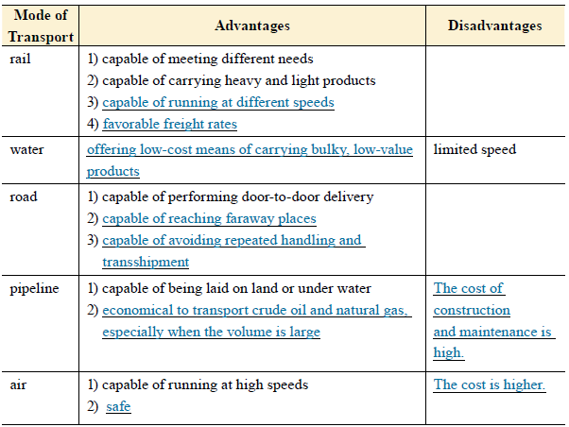

Task 2 5 minutes
Objective: Ss can understand the passage.
Steps:
•Ss do Task 2.
• Ask Ss to work individually.
• Check the answers.

Suggested Answers:
1. E 2. E 3. A, C 4. D 5. A 6. B 7.B 7. A, C

Task 3
Objective: Ss can speak well based on the topic of Reading A.
Steps:
•Ss do Task 3.
• Ask Ss to work in pairs.

Sample
Is that Mr. Franks? This is John Roberts at Quicksale. I am calling to apologize. I’m terribly sorry that the delivery of your earrings has been delayed. Our sales have increased a lot recently because Christmas is coming. Our delivery department simply could not cope with the extra workload. I’ve talked with our delivery department and they promised that the earrings will be delivered by tomorrow morning.

Language lab 45 minutes
Task 1 5 minutes
Objective: Ss know the spelling and meaning of the words and expressions from Reading A.
Steps:
• Ss read Task 1.
• Allow Ss 5 minutes to do the task.
• Check the answers.
Key
Key: 1. F 2. H 3. E 4. C 5. D 6. A 7. J 8. B 9. I 10. G

Task 2 10 minutes
Objective: Ss can use the words and expressions from Reading A.
Steps:
• Ss do Task 2.
• Ask Ss to work individually.
• Check the answers.

Answers
1. namely 2. delivery 3. give way to 4. transport
5. volume 6. lies in 7. advantageous 8. maintenance
9. bulky 10. economical

Task 3 10 minutes
Objective: Ss can express ideas in writing using the two models outlined for Task 3.
Steps:
• Read the models to Ss with an explanation if needed.
• Ss work in pairs.
• Check the answers.

Key:
Model 1
1. The cost of production is what we are thinking about right now.
2. Lack of water is not what causes the problem.
3. To accept the price is what he meant by saying “OK”.
Model 2
1. Sally has to finish the task in one day, which is very difficult for her.
2. John was late for the meeting again, which is very bad for a group leader.
3. They grew up in that village, which is something they can never change.

Task 4 10 minutes
Objective: Ss can express ideas in the words or expressions in the brackets.
Steps:
• Ss do Task 4.
• Ask Ss to work individually.
• Check the answers.

Key:
1. For some people, happiness simply lies in health and love.
2. To finish this report, we need more specific information instead of general descriptions.
3. Her writing is characterized by simple words and clear ideas.
4. Their products compare favorably with others’ in both quality and price.
5. Of all the five steps, the third one is optional.

Task 5 10 minutes
Objective: Ss can use the vocabulary in Reading A for translation.
Steps:
• Ss work individually or in pairs and translate the sentences.
• Ask two Ss to write their translations on the board.
• Comment briefly on their work with emphasis on the structures of their sentences.

Key:
1. This aircraft company began to deal with freight this year.
2. My problems are almost nothing in comparison with yours.
3. The door looks too wide in relation to its height.
4. Another company has offered more advantageous terms than yours.
5. The countryside gradually gave way to various buildings as the city grew.
6. Our hotel provides free breakfast for every guest.
7. The charge for the use of the public telephone is one yuan per time.

8. The two parties agreed to sign the contract.

Hours 4-5:

Listening 45 minutes
Task 1 5 minutes
Objective: Ss can answer the questions.
Script:
W: Hello, Customer Service Department. How can I help you?
M: Hello, I’m trying to find out if my order has been shipped.
W: OK. Could I have your order number, please?
M: Yes, it’s 9807.
W: Thank you. Wait a minute. Yes, your order was shipped on the eighteenth.
M: OK. Thanks.
W: You’re welcome. Bye.
M: Bye. y
Key: 1. 9807 2. On the eighteenth

Task 2 10 minutes
Objective: Ss can accurately write down the missing information.
Script & Key:
M: Could you deliver our goods by train?
W: Why? According to our contract we should deliver them by truck.
M: We hope we can receive the goods as soon as possible. It’s faster by train.
W: Don’t worry. We’ll have no trouble meeting your delivery date. And if a customer requests a carrier other than truck, he must bear the additional charges.
M: Well, in that case, we don’t insist on changing the mode of transport if you promise to deliver the goods on time.
W: All right. Thank you.

Task 3 10 minutes
Objective: Ss can understand the conversation and choose the best answer.
Script:
W: Well, Mr. Blare, let’s come to the next point— delivery date. What’s your time limit?
M: By the middle of March.
W: I see. But I have to point out that our factories have a lot of orders in hand. The best we can do is the last week in March.
M: You see, Mrs. Wilson, it’s essential for us to have it before the 25th. April is the selling season for this product in our market. If we miss the season, then we won’t make any profit.
W: What about making March 19th the shipment date?
M: Why the 19th?
W: That’s the last ship scheduled to sail for your port in March, and your order can reach you before the 25th. But we’ll do our best to push it as early as possible.
M: OK, let’s make it the 19th. We must insist absolutely on March 19th as the last possible date. But the earlier, the better.
W: Fair enough.
M: All right, then.

Q1: What are the two speakers talking about?
Q2: Why does the man have to have the products before April?
Q3: When will the products probably be shipped?
Key
Key: 1. A 2. D 3. B

Task 4 10 minutes
Objective: Ss can accurately write down the missing information.
Script:
W: Morning, Mr. Murphy. This is Julia. I’m phoning to inform you that the ship carrying your imports reached Shenzhen Port this morning and has started unloading in the afternoon.
M: Ah, good news. Would you tell me when we can expect the goods to arrive at our warehouse?
W: Yes, there are three containers in all. The trucks should arrive late Wednesday or early Thursday. It depends on traffic and weather. When will you accept deliveries?
M: We can start unloading the trucks at as early as 8:00 a.m. and as late as 4:00 p.m.
W: If our trucks arrive late in the afternoon on Friday, can you unload them on Saturday?
M: I’m afraid not. You might have to wait till next Monday. Er… I’ll talk with our warehouse manager about this and come back to you tomorrow. What do you think?
W: Fine. I’ll be expecting your call. Till then, bye.
M: Bye.
Key
Key:
1. this morning 2. three
3. late Wednesday 4. warehouse manager

Task 5 10 minutes
Objective: Ss can find specific information from listening to a passage related to the theme.
Script & Key:
Getting your products to your customers on time, in good condition and at a reasonable cost, is very important. As for the means of shipping your products, that decision should be made on the basis of your business needs and budget.
Four main means of transport are used internationally. Road transport is the most popular choice for shipping goods within a country. Prices are different according to whether the shipment is a full-truck load or a less-than-full-truck load. The railway is another important means of transport within a country, particularly where roads are in poor condition. Air transport is the most expensive choice. However, it has the advantages of speed, reduced insurance and storage costs. Water transport is used mainly for heavy goods. It is the slowest but least expensive mode of transport.
Besides means of transport, you will also need to pay attention to product packaging and insurance. Packaging protects your goods from shipping damage. It is strongly recommended that you insure your products. Insurance protects you against financial loss when products are stolen, damaged, delayed or accidentally lost.

Speaking 45 minutes
Task 6 45 minutes
Objective: Ss are able to practice posting letters and parcels with the useful expressions.
Steps:
• Ss read Task 6.
• Ss work in pairs to practice posting letters and parcels.
• Ss complete the chart.
Suggested Answers
B: Good morning. What can I do for you?
A: Morning. I’d like to post this letter to London and a parcel to Sydney.
B: By surface mail or airmail?
A: I’m not sure. I have no idea of the delivery options. Can you give me some suggestions?
B: Are they urgent?
A: Yes. This letter is very important and urgent. The parcel is an ordinary one.
B: I see. You can send the letter by airmail and in express and the parcel by ordinary mail. Give me your letter.
A: Here you are. By the way, when will it get there?
B: It’ll take around five days to reach London by airmail, but the parcel will take much longer time. Fill in this form please. Write your name, address, and the contents. Here are the stamps. Put them on the back cover.
A: Thank you.
B: You are welcome.

Hours 6-7:

Reading B 45 minutes
New words 5 minutes
Objective: Ss can get familiar with the new words and expressions, etc.
Steps:
• Ss listen to the new words and expressions, etc.
• Ss read the new words and expressions, etc.

Fast reading 20 minutes
Objective: Ss can comprehend Reading B.
Steps:
• Ss read the passage.
• Provide help if needed.

Task 1 10 minutes
Objective: Ss can decide whether the following statements are true or false according to the passage.
Steps:
• Ss read the passage.
• Ss complete the task.
• Ss compare their work with others.
• Select Ss to present their work.
Key
Key: 1. T 2. F 3. F 4. F 5. T

Task 2 10 minutes
Objective: Ss can comprehend the information of the text.
Steps:
• Ss read the passage.
• Ss complete the task.
• Ss compare their work with others.
• Select Ss to present their work.

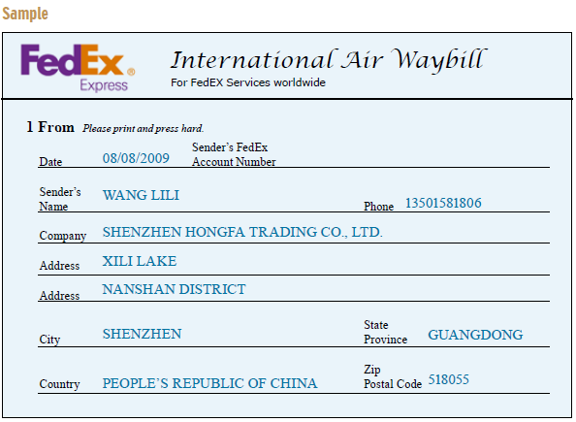

Writing 45 minutes
Task 1 20 minutes
Objective: Ss can get familiar with the style of letter of complaint.
Steps:
• Ss do the task individually.
• Ss compare with each other’s answers.
• Provide help if needed.
• Present the answers.

Key:
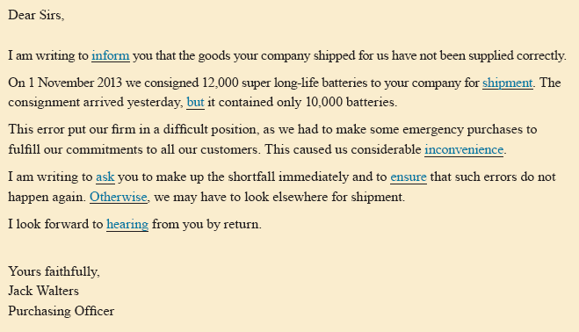

Task 2 25 minutes
Objective: Ss can get familiar with the style of letter of complaint.
Steps:
• Ss do the task individually.
• Ss compare with each other’s answers.
• Provide help if needed.
• Present the answers.

Key:
Dear Sirs,

I am writing to inform you that the shirt you sent me is in a wrong size.
I ordered a shirt (order No. 890560) in size 39 from your company online three weeks ago. But yesterday when I got the shirt, I found it was in size 40. Obviously, the size doesn’t fit me at all.

I’d be grateful if you could send me the right-sized shirt as soon as possible and refund my postage after I send the wrong-sized shirt back to your company.

I really appreciate your help.

Yours faithfully
Li Hong

Hour 8:

Mini-Project 40 minutes
Objective: Ss can know how to develop problem-solving and research skills.
Steps:
• Grouping. Divide the class into groups.
• Defining the project. Go through the project with the class and clarify requirements. You are advised to do it after Ss study Reading B.
• Timing & cooperation. Give Ss the deadline for completion and guidelines on working together. Ss discuss to decide who will log on which website and then compare the services of different companies.
• Co-working
1) Ss search online the luggage regulations.
2) Ss specify the luggage regulations in details.
3) Ask 2 or 3 groups to present their research results to the class.
4) Invite other groups to give comments.

Quiz 5 minutes

