Warming-up Exercise A
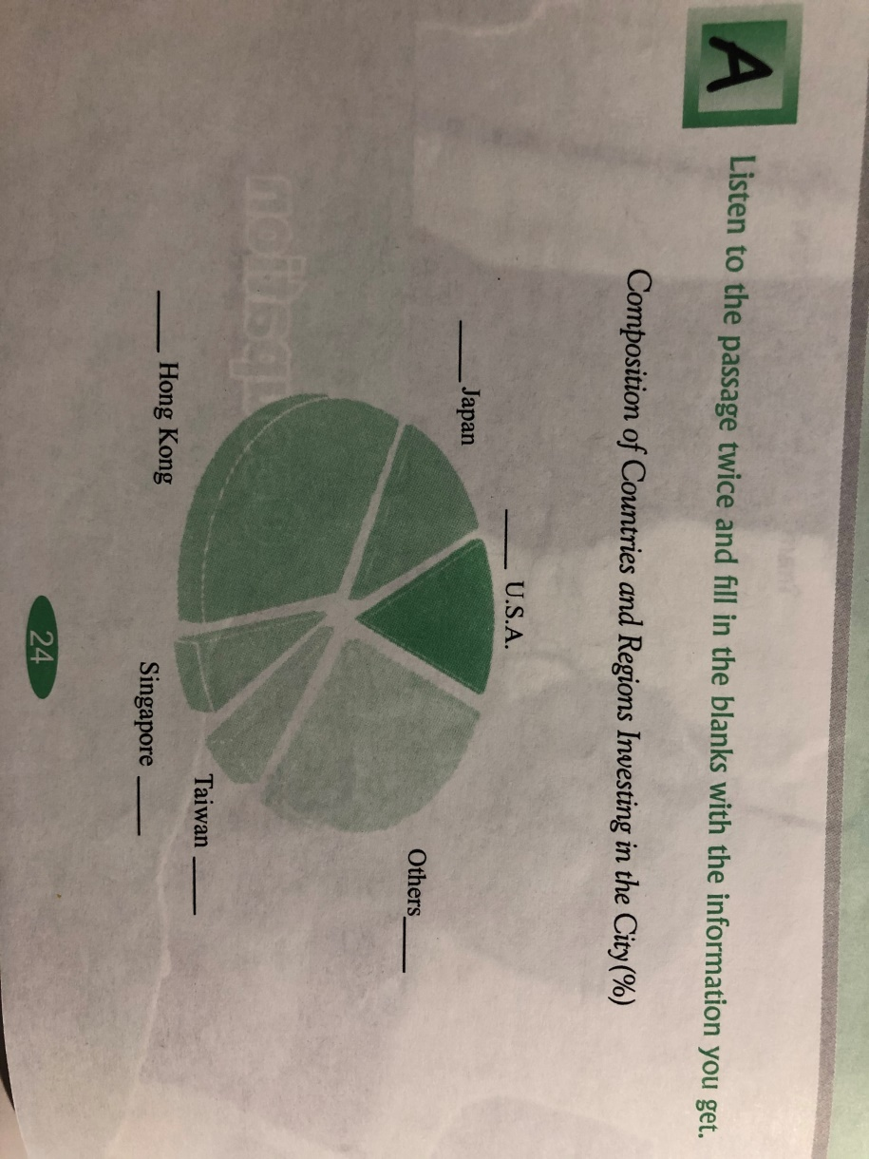
B
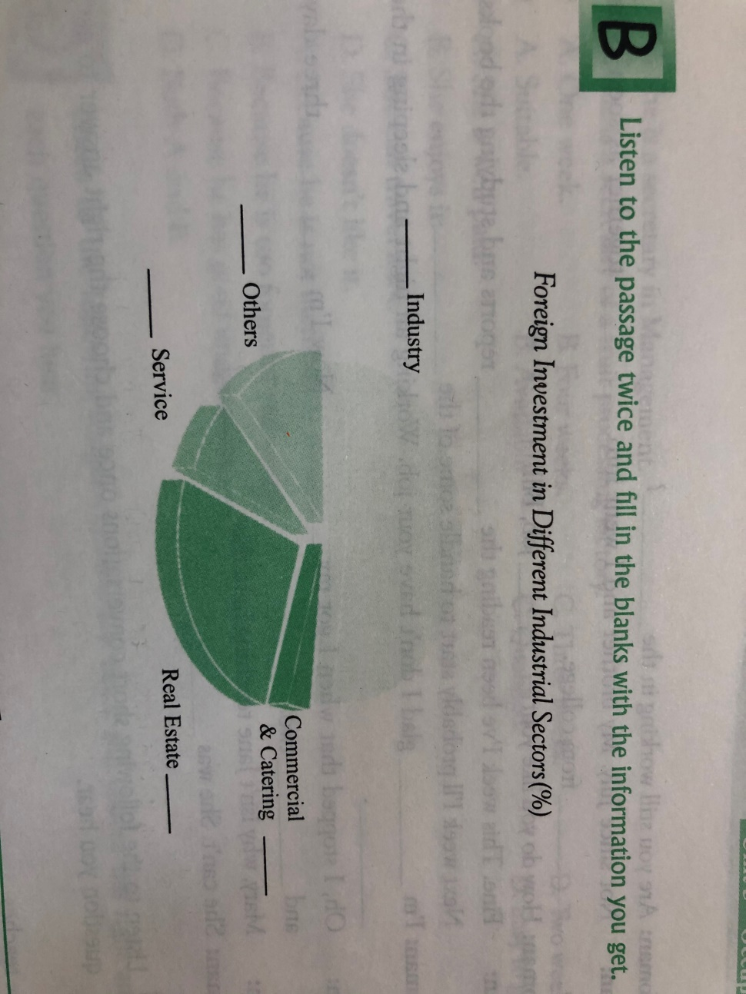
Conversation A
- Woman: How’s your new job with the company?
Man: It seemed at first, but I guess I’m no salesman. And to add fuel to the fire, the boss and I have our .
- Woman: Are you still working in the ?
Man: Not since July. My brother and I went into
together as soon as he from college.
- Woman: How do you like your job, Bill?
Man: Fine. This week I’ve been reading the
reports and studying the books. Next week I’ll probably start to handle some of the .
- Woman: I’m glad I don’t have your job. Working all night and sleeping in the .
Man: Oh, I stopped that when I got my . Now I’m
three days and two.
- Man: Mary, why isn’t Jane teaching here this ?
Woman: She can’t. She was .
BListen to the following short conversations once and choose the right answer to each question you hear.
- A. He teaches. B. He gives legal advice.
C. He studies. D. He teaches law.
- A. She is a school master.
B. She is a secretary.
C. She is a teacher.
D. She is a historian.
3 A. He was a bank clerk.
B. He was a doorkeeper.
C. He was a storehouse keeper.
D. He was a watchman.
4 A. She can type very well.
B. She has experience in shorthand.
C. She has learned typing.
D. She seldom makes mistakes in typing.
- A. Monday, Wednesday and Friday.
B. Saturday and Sunday.
C. Tuesday, Thursday and Sunday.
D. Monday, Friday and Saturday.

