Test 1
Part 1 Presentation (3 minutes)
Directions: You are asked to talk about the following chart on ads spending on internet and print in 2015. First, describe the chart, then analyze it and give possible reasons.
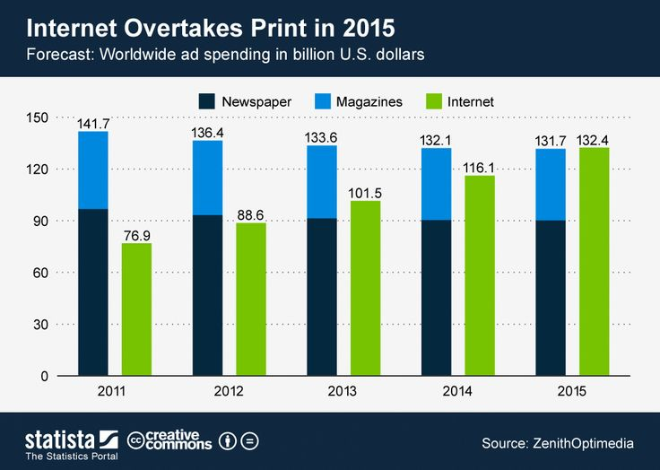

Part 2 Interview (3 minutes)
You will read a poster.
Suppose you are the organizer of the training sessions. A person who is interested comes to ask for some information. You are going to answer the questions.

Contestant：the organizer of the training sessions
Question master: a person who is interested.

