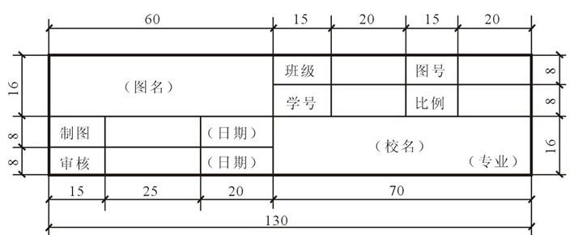
https://image.baidu.com/search/detail?ct=503316480&z=0&ipn=d&word=%E5%9B%BE%E7%BA%B8%E6%A0%87%E9%A2%98%E6%A0%8F&step_word=&hs=0&pn=0&spn=0&di=70762003290&pi=0&rn=1&tn=baiduimagedetail&is=0%2C0&istype=2&ie=utf-8&oe=utf-8&in=&cl=2&lm=-1&st=-1&cs=874223100%2C3363765736&os=2404315262%2C543829233&simid=4294434386%2C853077365&adpicid=0&lpn=0&ln=1924&fr=&fmq=1529915040876_R&fm=result&ic=0&s=undefined&se=&sme=&tab=0&width=&height=&face=undefined&ist=&jit=&cg=&bdtype=0&oriquery=&objurl=http%3A%2F%2Fwiki.zhulong.com%2Fupload%2Fother%2F2015%2F01%2F30%2F135b50b695114ad913f8422d20c8b8d9.jpg&fromurl=ippr_z2C%24qAzdH3FAzdH3Fotht_z%26e3Bzi7s5g2_z%26e3Bv54AzdH3F6jw109alld_z%26e3Bip4s&gsm=0&rpstart=0&rpnum=0&islist=&querylist=

